TOPIC

Computer Architecture

By

Name :مريم حلمى عبد الرحمن عواد يتيمة

B:N:883

Email: [mariam195985@feng.bu.edu.eg](mailto:mariam195985@feng.bu.edu.eg)

GitHub link : <https://github.com/Mariam-Retima/eceoo1>

GitHub page: <https://mariam-retima.github.io/eceoo1/>.

Application Brief

Computer architecture is a specification describing how hardware and software technologies interact to create a computer platform or system. When we think of the word architecture, we think of building a house or a building. Keeping that same principle in mind, computer architecture involves building a computer and all that goes into a computer system. Computer architecture consists of three main categories.

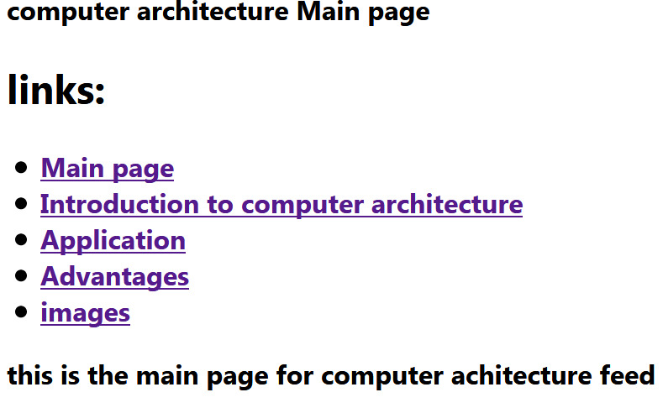

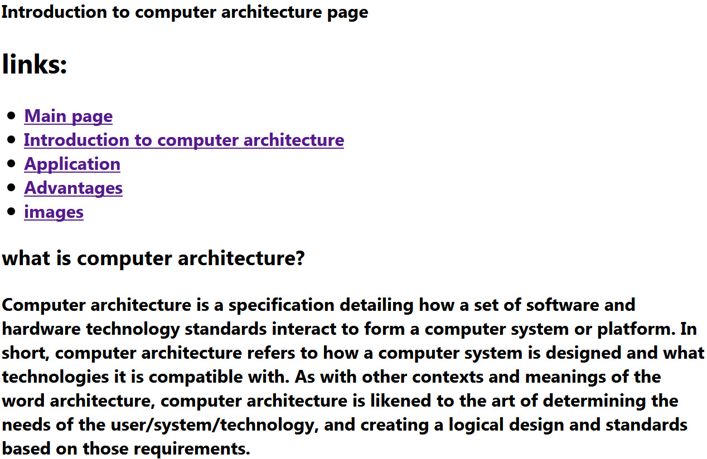

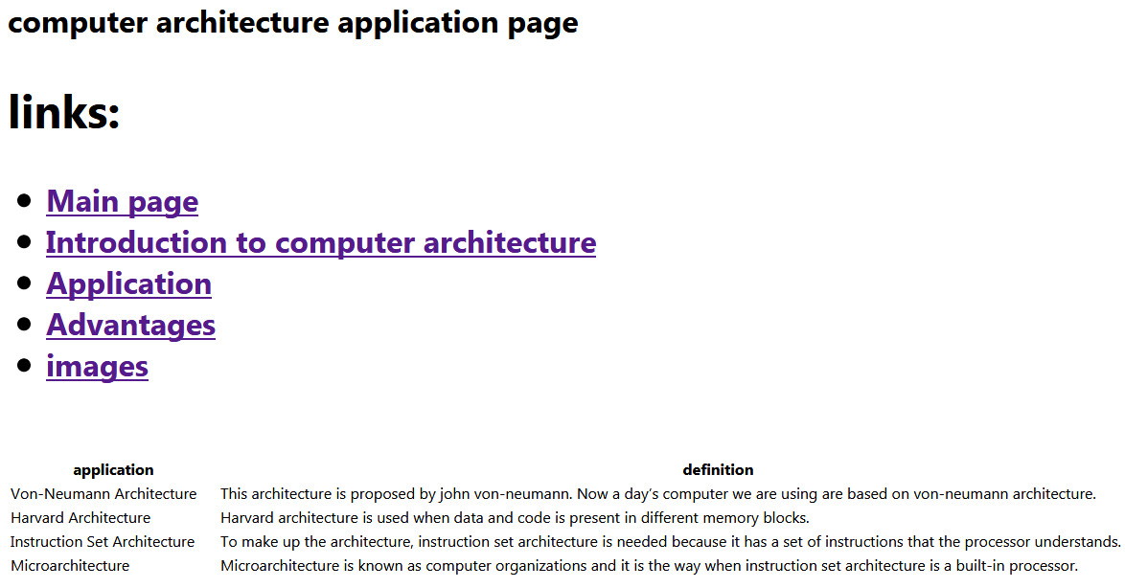

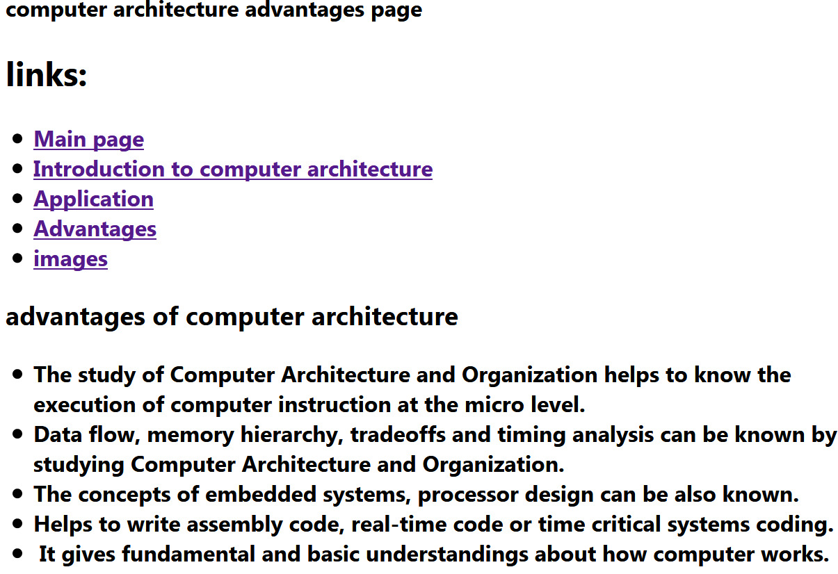

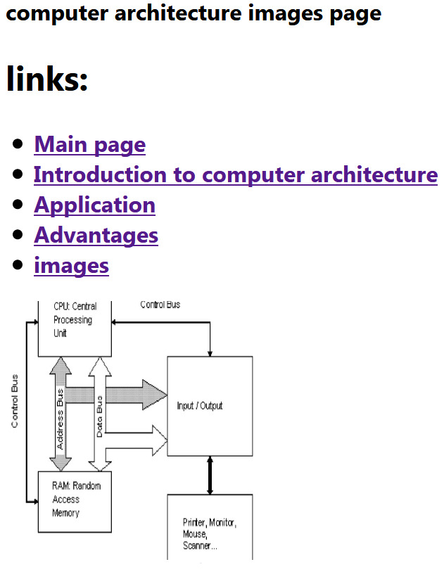

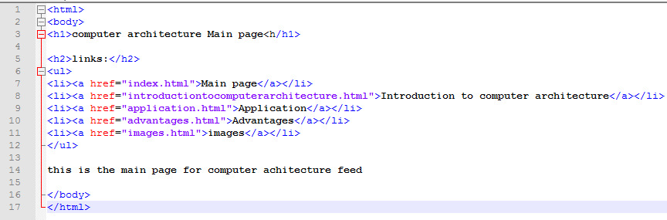**Source code**

